Boxes

1

Boxes

2

Everything is a box

• As mentioned and seen previously, every element in the body of the page is actually a rectangular *box*

▶ *block* element boxes always expand their width to ﬁll all available space

▶ *inline* element boxes do not. They merely surround the *content* of the element.

• By default, *block* element boxes *stack* vertically

3

Pink = inline, all others are block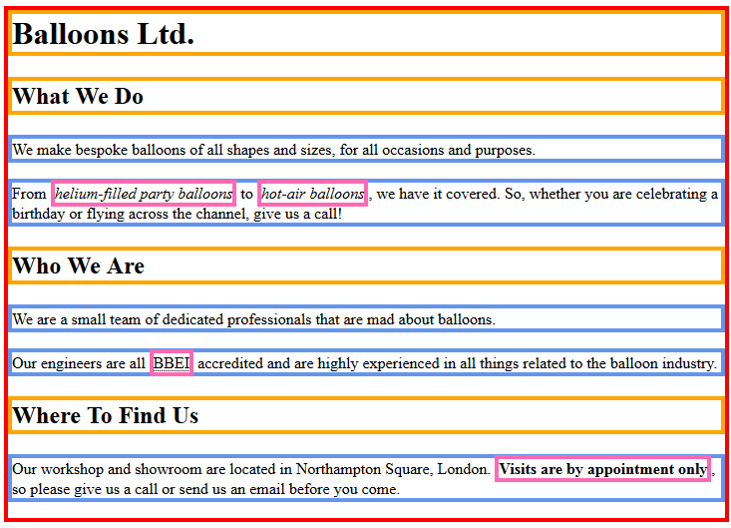

4

CSS and Boxes

• In CSS, *block* element boxes are described by the *box-model*

▶ *Inline* elements are too, but to a lesser extent

• The *box model* is concerned with the space occupied by an element

• Understanding the *box model* is the key to unlocking many of the secrets of CSS!

5

The Box model

• Every *box* consists of:

▶ A *content* area ▶ A *padding* area ▶ A *border* area ▶ A *margin* area

6

The Box model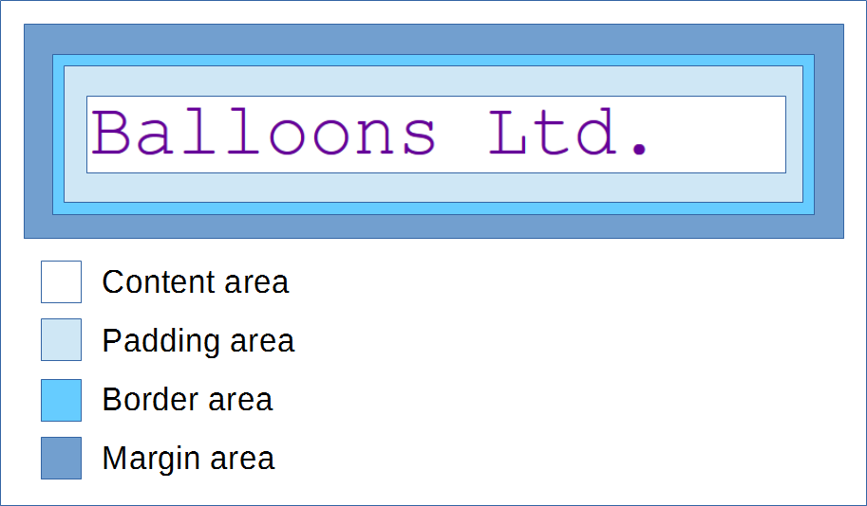

7

The *content* area

• The **content** area is the space which the element’s content will occupy

• By default:

▶ A *block* element’s content area expands in width to ﬁll all available space

▶ An *inline* element’s content area expands in width just enough to enclose the content

• The *height* of the content area is determined by the amount of content within the element

8

The *content* area and CSS

• With CSS, we can control both the *width* and *height* of the content area.

• However… it is complicated!

▶ We will revisit this aspect of the *box* later in the course.

9

The *border* area

• The *border area* represents the visible boundary of the element.

• By default, most elements have a zero-width border

▶ However, the border area is still present!

• As we will see, we can control the border colour, size and style with CSS

10

The *padding* area

• The *padding area* is the space between the *content area* and the *border*

• With CSS, we can control the amount of padding applied to each side of the *box*

• By default, most elements have no padding

▶ i.e. the *content area* touches the *border area* on all sides

11

The *padding* area defaults

• Some of the elements we have already used *do* have default padding

▶ Can you guess which ones?

12

The *margin* area

• The *margin area* is the *empty* space surrounding an element’s border

▶ i.e. it determines the space between the element and it’s neighbours

• With CSS, we can control the amount of margin applied to each side of the *box*

13

The *margin* area defaults

• By default, a lot of *block* elements have top and bottom margins applied to them

▶ E.g.: *h1-h6*, *p* (notice the space above and below each of these elements in your pages)

• However, by default, they have no left or right margin

14

CSS box properties

• All of these *box properties* can be manipulated and controlled with CSS

• We can set these properties on each *side* of the box individually

▶ Or, we can set them for all 4 sides at once

• We can also decorate the *box* with things like backgrounds, drop-shadows, etc.

15

Borders

16

Border properties

• We can customise the element’s border with the *border* family of properties

▶ *border-style* (what kind of line should be used) ▶ *border-width* (what size should the border be)

▶ *border-color* (what colour should the border be)

17

Property: border-style

• The *border-style* properties allows us to specify the type of line that will be used for the border

• The values we can use are:

▶ **solid**, **dotted** , **dashed** , **double** , **groove**, **ridge**, **inset**, **outset**, **none**, **hidden**

• The default value for most elements is **none**

18

Property: border-style

• To set the border style for each side of the box, we can use the properties:

▶ **border-top-style**

▶ **border-bottom-style** ▶ **border-left-style**

▶ **border-right-style**

19

Property: border-style - example 1

• To set diﬀerent styles on each side:

h1 **{**

**border-top-style:** solid**; border-right-style:** double**; border-bottom-style:** dashed**; border-left-style:** dotted**;**

**}**

20

Property: border-style - example 2

• To set the style for bottom and left sides (others will have no border)

h1 **{**

**border-bottom-style:** solid**; border-left-style:** solid**;**

**}**

• **Q:** Why will the top and right edges have no border?

21

Shorthand for border style

• CSS provides a *shorthand* property that can make life a bit easier for us

▶ The **border-style** property

• As the *value*, we can specify the desired styles for each side, separated by a space

• The order of the the values **must** be:

▶ **T** op, **R** ight, **B** ottom, **L** eft

• Or, we can specify a single value to apply to all sides

22

Border style shorthand example

• Set diﬀerent styles on each side:

h1 **{**

**border-style:** solid double dashed dotted**; }**

• To set the same style on all 4 sides:

h1 **{**

**border-style:** solid**; }**

23

Border style : Try it

• Open *index.html* from your *test* website in your code editor. If you do not have a *h1* element in the *body*, add one.

• Open the style sheet for your *test* website in your code editor and add this rule:

h1 **{**

**border-style:** solid**; }**

• Save your ﬁles and preview the page. Can you see

a border around the heading?

24

Property: border-width

• The *border-width* property allows us to set the thickness of the border

• The *value* can be any valid CSS unit of measurement (px, em, etc.)

▶ Commonly, we use *pixels* for border dimensions ▶ The default width of borders in FireFox is 3

pixels (other browsers may diﬀer)

25

Property: border-width

• To set the border width for each side of the box, we use the properties:

▶ **border-top-width**

▶ **border-bottom-width** ▶ **border-left-width**

▶ **border-right-width**

26

Border width - useless on it’s own

• When setting the *width* of the border, we still have to set the *border-style*

▶ Without a *border-style* declaration, the

*border-width* declarations would have no eﬀect.

• The same is true for all other border properties

• Why?… because the default value for *border-style* is *none*

▶ *none* = no border

27

Property: border-width - example 1

• To set diﬀerent widths on each side:

h1 **{**

**border-style:** solid**; border-top-width:** 5px**; border-right-width:** 20px**; border-bottom-width:** 30px**; border-left-width:** 40px**;**

**}**

28

Property: border-width - example 2a

• To set the width for selected sides (top & bottom)

h1 **{**

**border-style:** solid**; border-top-width:** 5px**; border-bottom-width:** 30px**;**

**}**

• **Q:** What will happen with the left and right borders?

29

Property: border-width - example 2b

• In this case, if we want to remove the left and right borders, we have to set their width to **0**

h1 **{**

**border-style:** solid**; border-top-width:** 5px**; border-right-width:** 0**; border-bottom-width:** 30px**; border-left-width:** 0**;**

**}**

• **Q:** Could we achieve the same result with diﬀerent

rules?

30

Shorthand for border width

• Just like *border-style*, there is also a shorthand we can use to set the border width:

▶ **border-width**

• Again, we can specify 4 values in the order: **T** op, **R** ight, **B** ottom, **L** eft

• Or we can specify a single value to apply to all 4 sides

31

Shorthand: border-width example

• Set diﬀerent widths on each side:

h1 **{**

**border-style:** solid**;**

**border-width:** 5px 20px 30px 40px**; }**

• Set the width on all 4 sides to 5 pixels:

h1 **{**

**border-style:** solid**; border-width:** 5px**;**

**}**

32

Border width: Try it

• Open the style sheet for your *test* website in your code editor

• Add a *border-width* declaration to your *h1* rule:

h1 **{**

**border-style:** solid**; border-width:** 10px**;**

**}**

• Save your ﬁles and preview the page. Is the border thicker than before?

33

Property: border-color

• By default, the colour of the borders will be the same as the colour of the element’s text

• We can change this with the *border-color* property

• The *values* we can use are the same as for *color*

▶ Colour keywords, Hexadecimal, RGB, Etc.

34

Property: border-color

• To set the border colour for each side of the box, we use:

▶ **border-top-color**

▶ **border-bottom-color** ▶ **border-left-color**

▶ **border-right-color**

35

Property: border-color - example 1

• To set diﬀerent border colours for each side:

h1 **{**

**border-style:** solid**; border-width:** 5px**;**

**border-top-color:** #ff0000**; border-right-color:** #0000ff**; border-bottom-color:** #ff6600**; border-left-color:** #00ff00**;**

**}**

36

Property: border-color - example 2

• To set the colour of the top and bottom borders:

h1 **{**

**border-style:** solid**; border-width:** 5px**;**

**border-top-color:** #ff0000**; border-bottom-color:** #ff6600**;**

**}**

• **Q:** What colour will the left and right borders be?

37

Shorthand for border colours

• There is also a shorthand property we can use to set the border colour:

▶ **border-color**

• Again, we can specify 4 values in the order: **T** op, **R** ight, **B** ottom, **L** eft

• Or we can specify a single value to apply to all sides

38

Shorthand border-color example 1

• To set the colour for all 4 sides to orange:

h1 **{**

**border-style:** solid**; border-width:** 5px**; border-color:** #ff6600**;**

**}**

39

Shorthand border-color example 2

• To set diﬀerent colours for each side:

h1 **{**

**border-style:** solid**; border-width:** 5px**;**

**border-color:** #ff0000 #0000ff #ff6600 #00ff00**; }**

40

Border color : Try it

• Open the style sheet for your *test* website in your code editor

• Add a *border-color* declaration to the *h1* rule:

h1 **{**

**border-style:** solid**; border-width:** 10px**; border-color:** #ff6600**;**

**}**

• Save your ﬁles and preview the page.

41

Shorter Shorthand for borders

• If you are setting the same *style*, *width* and *color* on all four sides, there is another shorthand property you can use:

▶ **border**

• For the value, we use the values for:

▶ [border-width] [border-style] [border-color]

• The *values* are separated by spaces

42

Shorthand: border example

• This code:

h1 **{**

**border-style:** solid**; border-width:** 5px**; border-color:** #ff6600**;**

**}**

• Can be rewritten as this:

h1 **{**

**border:** 5px solid #ff6600**; }**

43

Shorter shorthand - speciﬁc sides

• There is also a shorthand that allows us to set all of the border properties for a speciﬁc side in one line:

▶ **border-top**

▶ **border-right**

▶ **border-bottom** ▶ **border-left**

44

Shorter shorthand - example

• To set all of the properties for the *top* border at once:

h1 **{**

**border-top:** 5px solid #ff6600**; }**

• Will there be any border on the other 3 sides?

45

Border shorthand: Try it

• Open the style sheet for your *test* website in your code editor

• Change your *h1* rule to look like this:

h1 **{**

**border:** 10px solid #ff6600**; }**

• Save your ﬁles and preview the page (there should be no visible change).

46

Border shorthand: Try it again

• In your *test* website’s *index.html* , make sure you have at least one paragraph in the *body*

• In your style sheet, add the following rule:

p **{**

**border-bottom:** 3px dotted #0099ff**; }**

• Save your ﬁles and preview the page. Does the paragraph have a bottom border?

47

Backgrounds

48

Background properties

• We can also use CSS to apply a *background* to an element’s box

▶ We can specify a solid colour

▶ We can specify background images (More on this later in the course)

• By default, most elements have a *transparent* background

49

Background coverage

• When we set the background for an element, it will cover:

▶ The *content* area ▶ The *padding* area

▶ The *border* area (but underneath the border)

• The *margin* area will **not** have a background

50

Property: background-color

• To set a solid colour as the background, we use the property:

▶ **background-color**

• For the *value*, we can use the same values we used for *color* and *border-color*

▶ Colour keywords, Hexadecimal, RGB, Etc.

51

Property: background-color - example

• To give an element an orange background:

h1 **{**

**background-color:** #ff6600**; }**

52

Background color: Try it

• Open the style sheet for your *test* website in your code editor

• Add a *background-color* declaration to your *h1* rule:

h1 **{**

**border:** 10px solid #ff6600**; background-color:** #ffb380**;**

**}**

• Save your ﬁles and preview the page. Can you see the background colour?

53

Margin and Padding

54

About Margin and Padding

• Both of these properties are very similar

▶ They both deﬁne a region of *space*

▶ They both accept the same kind of *values*

• The *values* we can use with them are any valid CSS unit of measurement:

▶ *em*, *pixels*, *%*, Etc.

55

Margin and Padding - the diﬀerence

• The diﬀerence between the two properties is:

▶ **margin** creates space *outside* the *visible* box ▶ **padding** creates space *inside* the *visible* box

• Note, if an element has no border or background, these properties will appear to do the same thing!

56

Margin and Padding values

• When setting the values for these properties, we can set them individually:

▶ **padding-top** , **padding-right** , **padding-bottom** , **padding-left**

▶ **margin-top**, **margin-right**, **margin-bottom**, **margin-left**

• Or, we can use the shorthand for each:

▶ **padding** ▶ **margin**

57

Margin and Padding units of measure

• It is common to use *em* units for margin and padding values

▶ Where: *1em* = 1 x Element’s font-size

• Why?… if we increase the *font-size* of an element, or the user increases the *default font-size* in their browser:

▶ the margin and padding will increase proportionally (a good thing!).

58

Setting margin/padding individually

• Add *1em* of space *inside the box* on the left side only:

h1 **{**

**padding-left:** 1em**; }**

• Add *2em* of space *outside the box* on the bottom side only:

h1 **{**

**margin-bottom:** 2em**; }**

59

Margin and Padding shorthand

• When using the shorthand syntax:

▶ We can specify 4 values in the order: **T** op, **R** ight, **B** ottom, **L** eft

▶ Or we can specify a single value to apply to all 4 sides

• Just like we did with the border shorthands

60

Margin and Padding shorthand example 1

• Add *1em* of space *inside the box* on the left side only:

h1 **{**

**padding:** 0 0 0 1em**; }**

• Add *1em* of space *outside the box* on the bottom side only:

h1 **{**

**margin:** 0 0 1em 0**; }**

61

Margin and Padding shorthand example 2

• Add *1em* of space *inside the box* on all sides:

h1 **{**

**padding:** 1em**; }**

• Add *2em* of space *outside the box* on all sides:

h1 **{**

**margin:** 2em**; }**

62

Padding: Try it

• Open the style sheet for your *test* website in your code editor

• Add a *padding* declaration to your *h1* rule:

h1 **{**

**border:** 10px solid #ff6600**; background-color:** #ffb380**; padding:** 1em**;**

**}**

• Save your ﬁles and preview the page.

63

Margin: Try it

• Open *index.html* from your hello website in your code editor and make sure there is a paragraph below the *h1* element. If there is not, add one with a few words in it.

• Preview your page and note the amount of space between the heading box and the paragraph

• Continued on next slide…

64

Margin: Try it

• In your style sheet, add a *margin-bottom* declaration to the *h1* rule:

h1 **{**

**border:** 10px solid #ff6600**; background-color:** #ffb380**; padding:** 1em**;**

**margin-bottom:** 5em**; }**

• Save your ﬁles and preview your page. Notice what has changed?

65

Exercise

• Now do the *Boxes exercise*

66

Good to know…

67

Inheritance and the box model

• Unlike the text properties we used previously, box-model properties are **not** inherited by an element’s children.

• They only apply to the element on which they are used.

body **{**

**font-family:** Arial**;** */* Inherited by children */* **border:** 1px solid #000**;** */* Not inherited*/*

**}**

68

Regarding shorthands

• For all of the shorthand properties that accept either *one* or *four* values, you may also see them speciﬁed with *two* or *three* values:

h1 **{**

**padding:** 1em 2em**; margin:** 1em 2em 3em**;**

**}**

• **Q:** Can you guess what these do?

69

Shorthand values

• **Two values:** the ﬁrst value is applied to the *top* and the *bottom*, the second is applied to the *left* and *right*

• **Three values:** the ﬁrst value applies to the *top*, the second applies to the *left* and *right*, the third applies to the *bottom*

70

Regarding Inline boxes

• All the examples utilise *block* elements (h1, p, etc.)

• When used with *inline* elements, they may appear to be broken

▶ In particular, top and bottom margins

• Due to the way *inline* elements are used, this is not a problem

71